**WEKA ASSIGNMENT**

**BY: PRANAV G**

**1. DATASET DESCRIPTION:**

Dataset Name: contact-lenses

Source of the dataset: <https://github.com/caiomsouza/data-science/blob/master/weka-datasets/data/contact-lenses.arff>

Dataset description: The data set contains 1 classes of 57 instances each where each class refers to a type of iris plant.

No of attributes: 5

No of instances: 24

**2. INPUT & OUTPUT:**

|  |  |  |
| --- | --- | --- |
| LABOUR | 1.Age  2. Spectacle-prescrip  3.Astigmatism  4.Tear-prod-rate  5.Contact lenses | Duration: class  Age: class  Spectacle-prescrip: class  Astigmatism: class  Tear-prod-rate: class  Contact lenses: class |

**3. DATA PREPARATION:**

Removal of null data types, empty instances and false attribute.

**4. SELECTING AN ALGORITHM:**

|  |  |  |
| --- | --- | --- |
| **Algorithm** | **Result from Weka** | |
| **Correctly Classified Instances** | **Mean Absolute Error** |
| **Weka Classifiers** | | |
| Bayes Net | 17 | 0.2306 |
| NaiveBayesMultinominalText | 15 | 0.3778 |
| NaiveBayesUpdateable | 17 | 0.2545 |
| **Weka Classifiers Functions** | | |
| Logistic | 16 | 0.2241 |
| MultilayerPerceptron | 17 | 0.2072 |
| **Weka Classifiers Meta** | | |
| AdaBoostM1 | 17 | 0.3581 |
| Stacking | 15 | 0.3778 |
| **Weka Classifier Trees** | | |
| J48 | 20 | 0.15 |
| RandomTree | 17 | 0.2083 |
| **Weka Classifier Rules** | | |
| DecisionTable | 18 | 0.2979 |
| OneR | 17 | 0.1944 |

**5.DATA PREPROCESSING:**

|  |  |
| --- | --- |
| **Attribute Evaluator** | Classifier Subset Eval (Classifier: meta.Stacking with training parameter: classifiers = J48 and the others in their default) |
| **Search Method** | BestFirst (Direction: Forward) |
| **Evaluation Mode** | 10-fold cross-validation (Folds = 10, Seed =1) |

**6.TREE PRODUCED:**

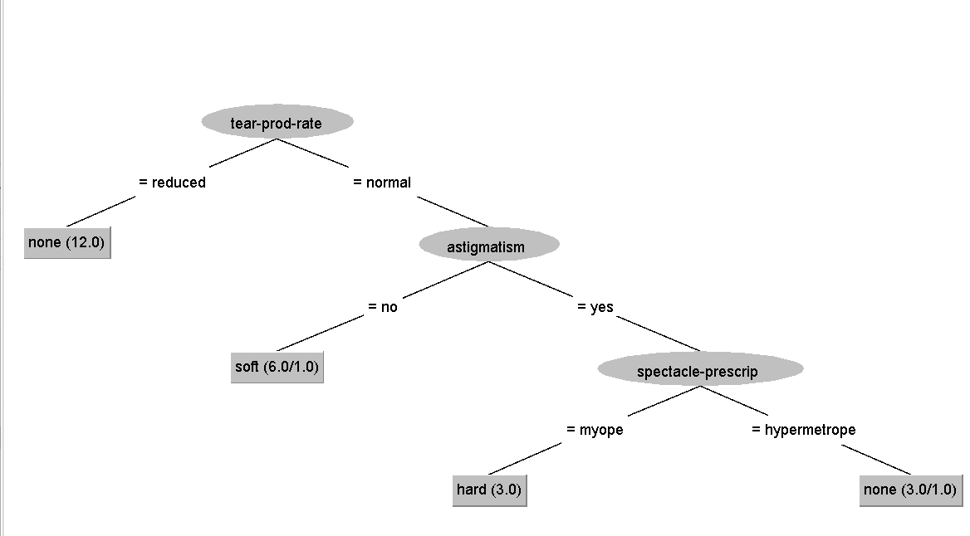

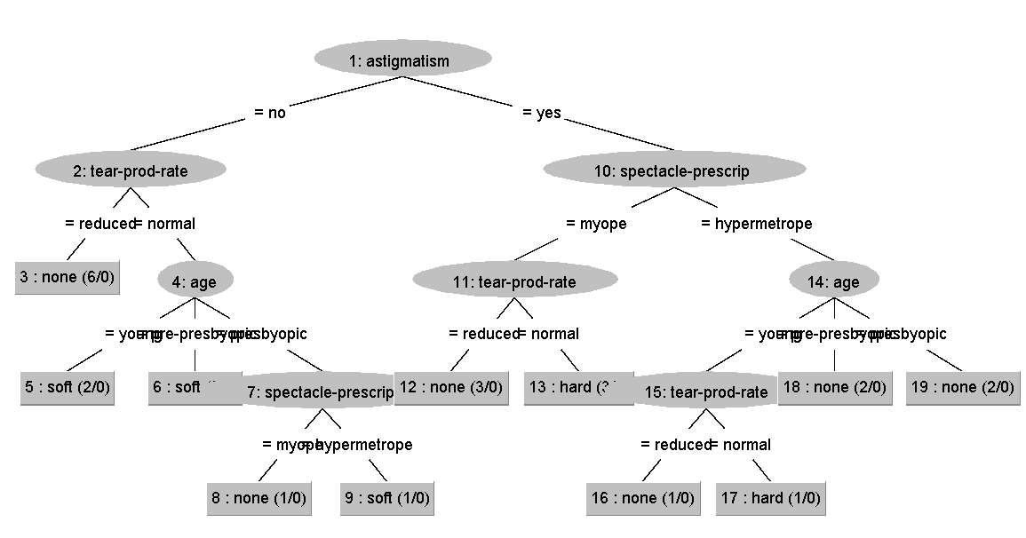

**7. SCREENSHOTS:**



